1.

C Program:

1 #include <stdio.h>
2 #include <math.h>
3 typedef struct point{
4 int coordinates[3];
5 }point;
6
7 float distance(point p, point q){
8 float sum = 0;
9 int i;
10
11 for (i=0;i<3;i++){
12 int a = (p.coordinates[i]-q.coordinates[i]);
13 sum+=pow(a,2);
14 }
15 return sqrt(sum);
16
17 }
18
19 void main(){
20 int i,j;
21 point p[3];
22 printf("Enter the vertices: \n");
23 for (i=0;i<3;i++){
24 printf("Enter (x,y,z) for vertex %d : ",i+1);
25 for (j=0;j<3;j++){
26 scanf("%d",&p[i].coordinates[j]);
27 }
28 }
29
30 float a = distance(p[0],p[1]);
31 float b = distance(p[1],p[2]);
32 float c = distance(p[0],p[2]);
33
34
35 if ( a==b && b==c && c==a){
36 printf("Equilateral\n");
37 }
38 else{
39 printf("Not Equilateral\n");
40 }
41 }

Input/Output:

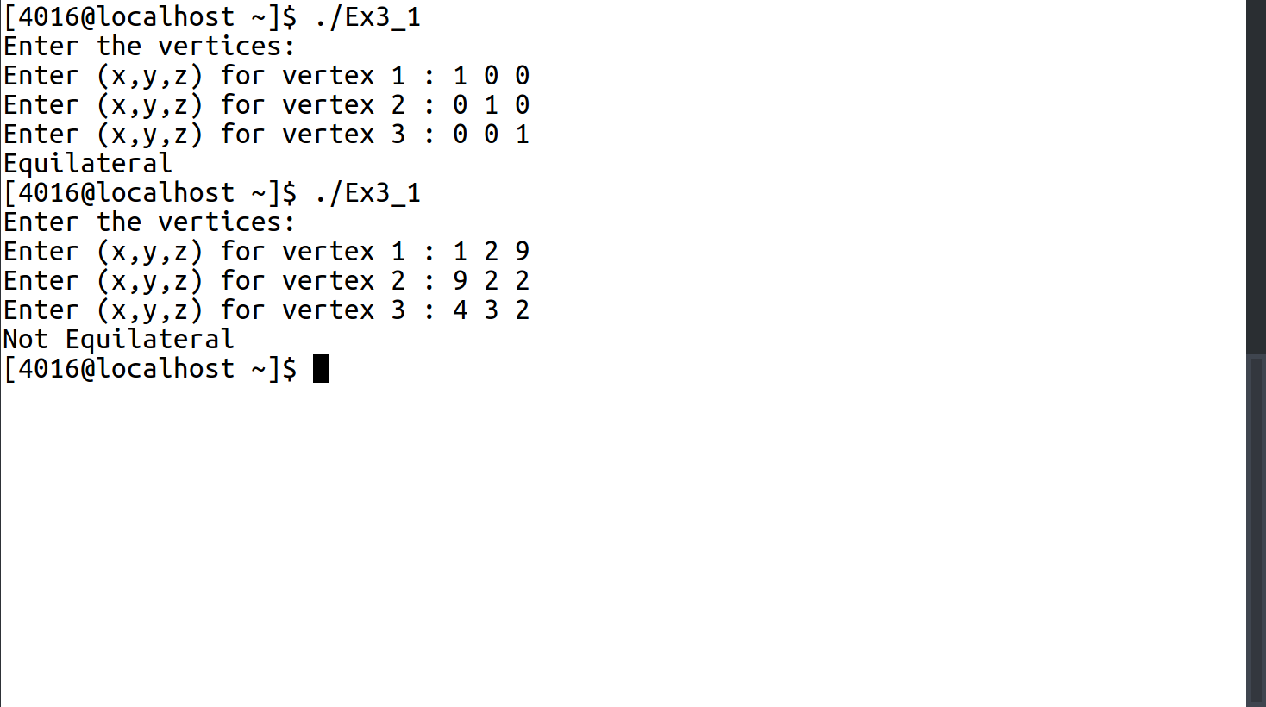

2.

C Program:

1 #include <stdio.h>
2 #define N 5
3 typedef struct med{
4 int medID;
5 char name[50];
6 char vendor[50];
7 int manDate[2];
8 int expDate[2];
9 int price;
10 int stock;
11 }med;
12
13 int check(med m[N], int a, int *size){
14 int ll=0;
15 int ul=*size-1;
16 int retVal = -1;
17 while(ul>=ll){
18 int mid = (ul+ll)/2;
19 if (m[mid].medID == a){
20 retVal = mid;
21 break;
22 }
23 else if(m[mid].medID > a){
24 ll=mid+1;
25 }
26 else if(m[mid].medID < a){
27 ul=mid-1;
28 }
29 }
30 return retVal;
31 }
32
33 void insert(med m[N], med n, int *size){
34 int i = *size-1;
35 while(n.medID>m[i].medID && i>=0){
36 m[i+1]=m[i];
37 i--;
38 }
39 m[i+1]=n;
40 *size += 1;
41 }
42
43 void input(med n[N], int *size){
44 med m;
45 int i;
46 printf("Enter Details \n");
47
48 printf("Enter the ID of the Medicine: ");
49 scanf("%d%*c",&m.medID);
50 printf("Enter Name of Medicine: ");
51 fgets(m.name,49,stdin);
52 printf("Enter Vendor of Medicine: ");
53 fgets(m.vendor,49,stdin);
54 printf("Enter Price of Medicine: ");
55 scanf("%d%*c",&m.price);
56 printf("Enter Stock of Medicine: ");
57 scanf("%d%*c",&m.stock);
58 printf("Enter Date of Manufacure of Medicine as MM/YY: ");
59 scanf("%d/%d%*c",&m.manDate[0],&m.manDate[1]);
60 m.expDate[1] = m.manDate[1] + 1;
61 m.expDate[0] = m.manDate[0];
62 insert(n,m,size);
63
64 }
65
66
67 void buy(med m[N], int a, int *size){
68 int index = check(m,a,size);
69 if(index!=-1){
70 int n;
71 printf("How many to buy: \n");
72 scanf("%d",&n);
73 m[index].stock+=n;
74 printf("%d medicines purchased\n",n);
75 }
76 else{
77 printf("This medicine is not in the database: \n");
78 input(m, size);
79 }
80
81 }
82
83 void sell(med m[N], int a, int *size){
84 int index = check(m,a,size);
85 if(index!=-1 && m[index].stock > 0){
86 int n;
87 printf("How many to sell: \n");
88 scanf("%d",&n);
89 if(n<=m[index].stock){
90 m[index].stock-=n;
91 printf("%d units sold\n",n);
92 }
93 else{
94 printf("Insufficient Stock\n");
95 }
96 if(m[index].stock < 5){
97 printf("WARNING : Only %d stock left.\n",m[index].stock);
98 }
99 }
100 else{
101 printf("That medicine is not available \n");
102 }
103 }
104
105
106
107
108 void display(med m[N],int *size){
109 int i;
110 printf("Medicine ID\tName\tVendor\tPrice\tManufacture Date\tExpiry Date\tStock\n");
111 for(i=0;i<*size;i++){
112 printf("%d\t %s\t %s\t %d\t %d/%d\t %d/%d\t %d\t\n",m[i].medID,m[i].name,m[i].vendor,m[i].price,m[i].manDate[0],m[i].manDate[1],m[i].expDate[0],m[i].expDate[1],m[i].stock);
113 }
114 }
115
116
117 void main(){
118 med m[N];
119 int size,i,entry;
120 printf("Enter how many Medicines\n");
121 scanf("%d",&entry);
122 for(i=0;i<entry;i++){
123 input(m,&size);
124
125 }
126 int choice = 1;
127 int query=0;
128 while(choice!=0){
129 printf("1.Buy\n2.Sell\n3.Check Availability\n4.Display\n0.Exit\n");
130 scanf("%d",&choice);
131 switch (choice){
132 case 1:
133 printf("Enter ID of Medicine to Purchase\n");
134 scanf("%d",&query);
135 buy(m,query,&size);
136 break;
137 case 2:
138 printf("Enter ID of Medicine to Sell\n");
139 scanf("%d",&query);
140 printf("%d",query);
141 sell(m,query,&size);
142 break;
143 case 3:
144 printf("Enter ID of Medicine to Check\n");
145 scanf("%d",&query);
146 printf("There is %d stock left\n",m[check(m,query,&size)].stock);
147 break;
148 case 4:
149 display(m,&size);
150 break;
151 }
152
153 }
154 }

Input/Output:

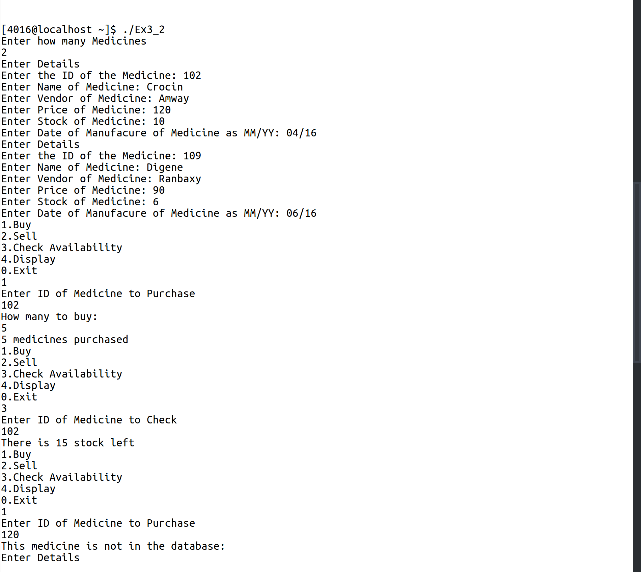
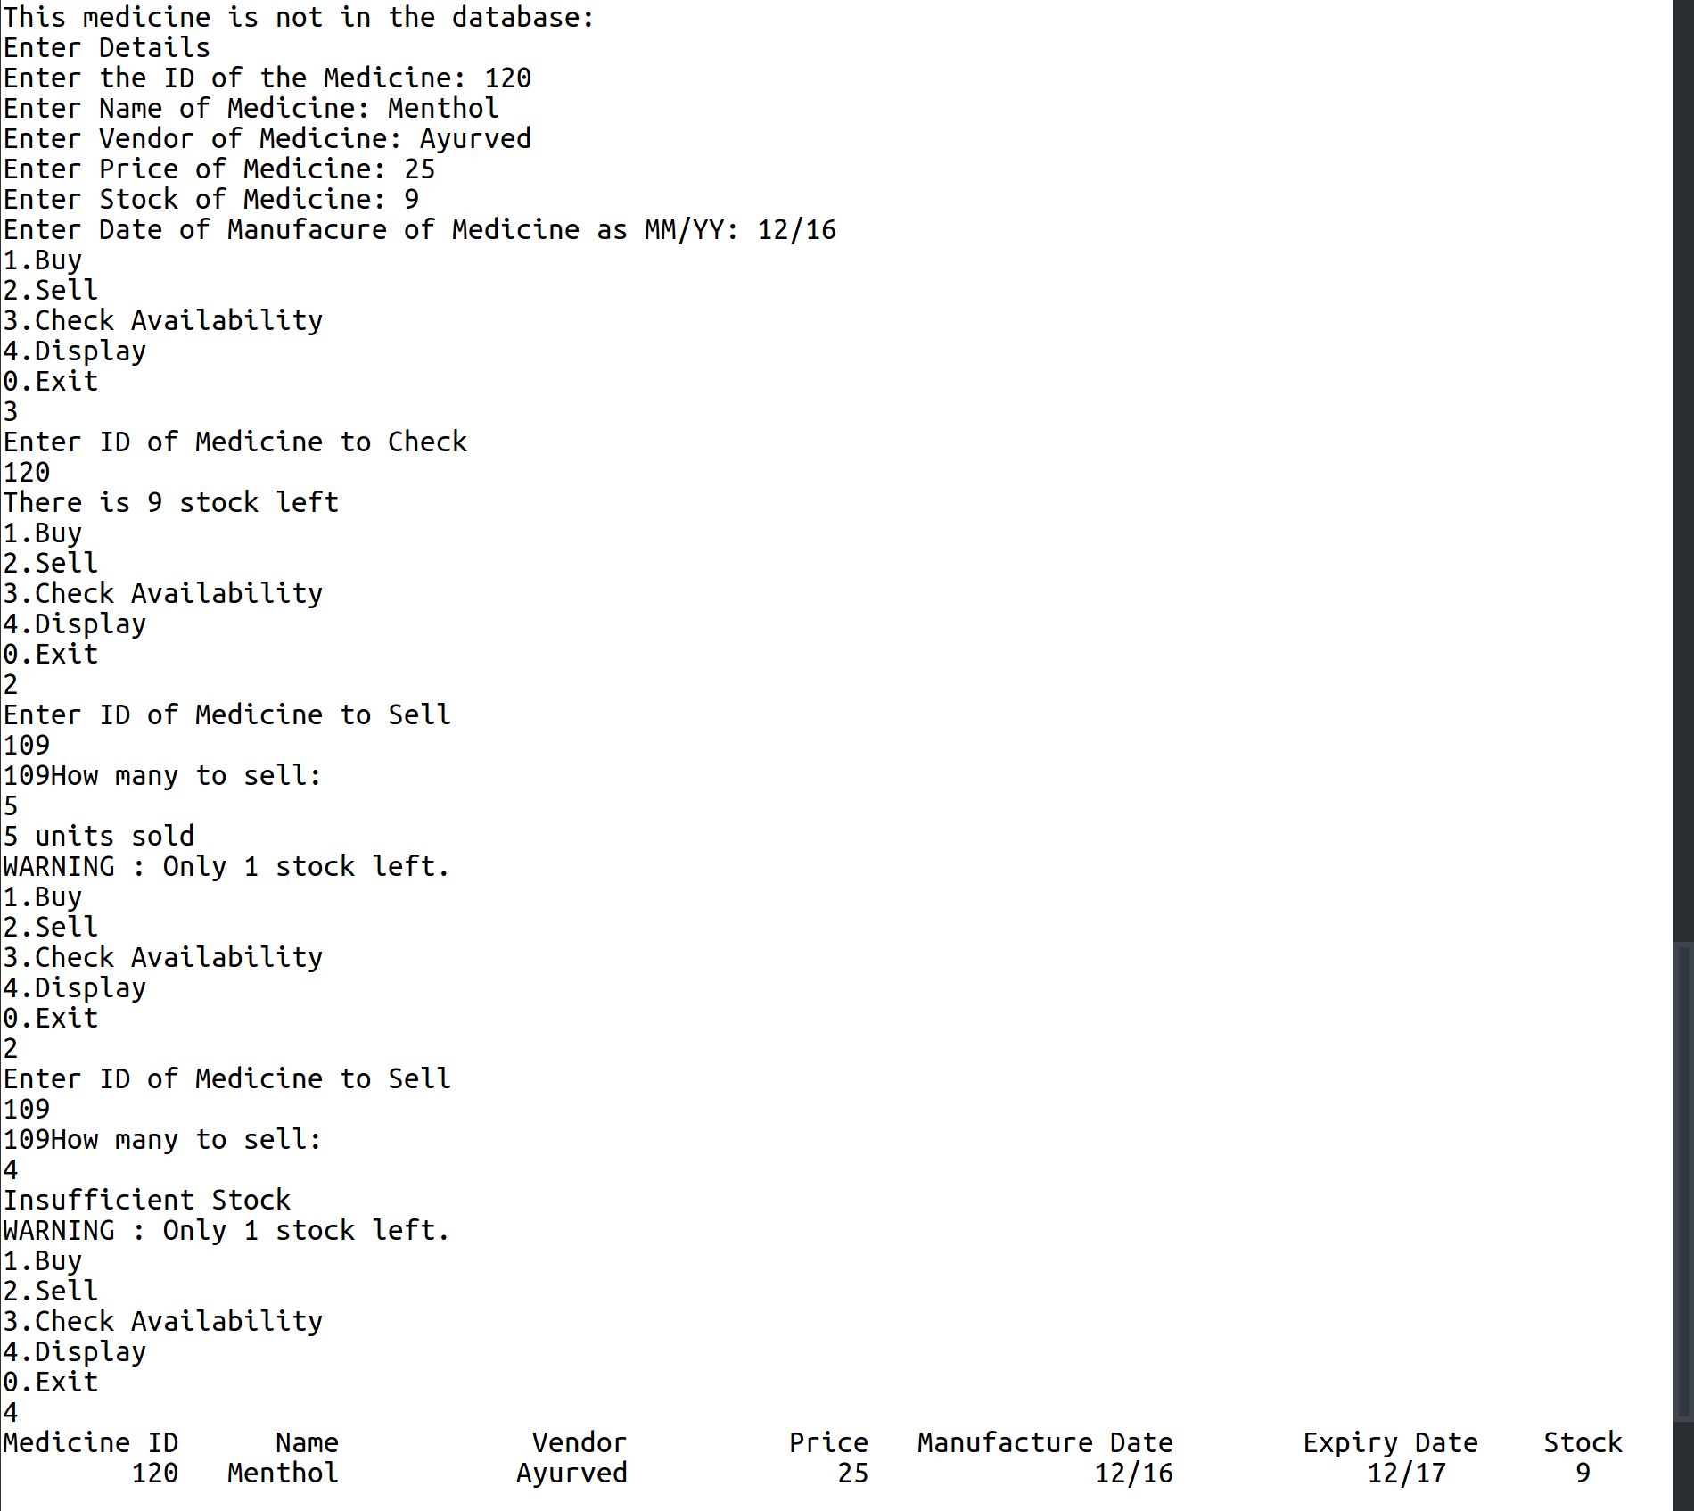
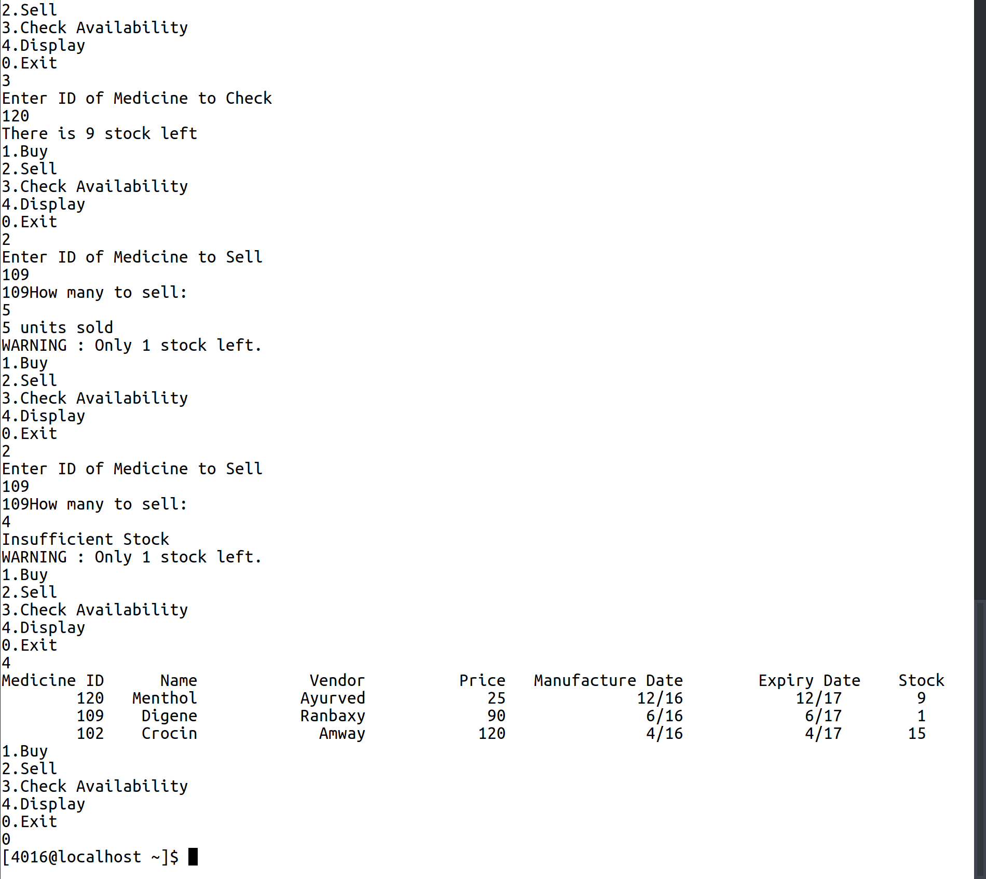

3.

C Program:

1 #include <stdio.h>
2
3 typedef struct structs{
4 int i;
5 float f;
6 char c;
7 }structs;
8
9 typedef union unions{
10 int i;
11 float f;
12 char c;
13 }unions;
14
15 void main(){
16 int i;
17 float f;
18 char c;
19 structs s;
20 unions u;
21 printf ("Enter an integer, float and a character \n");
22 scanf("%d %f %c",&i,&f,&c);
23 s.i = u.i = i;
24 s.f = u.f = f;
25 s.c = u.c = c;
26 printf("Size of the Struct: %d\n", sizeof(s));
27 printf("Size of the Union: %d\n",sizeof(u));
28 printf("Values stored in the Struct: %d %f %c \n",s.i,s.f,s.c);
29 printf("Values stored in the Union: %d %f %c \n",u.i,u.f,u.c);
30 }

Input/Output:

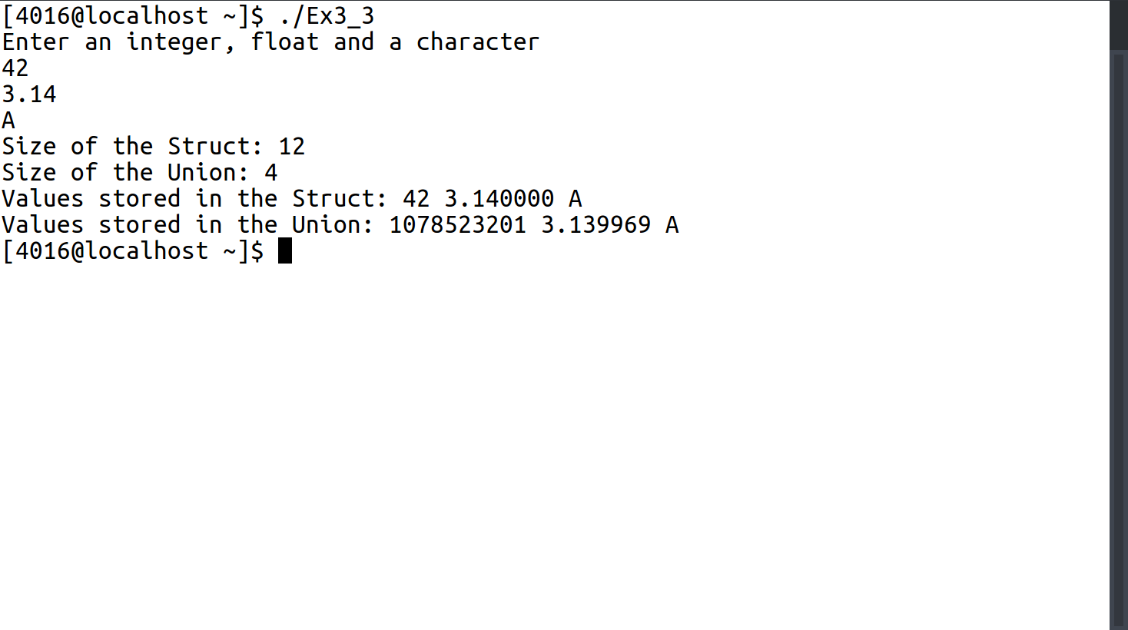

4.

C Program:
1 #include <stdio.h>
2 #define N 5
3 typedef struct phone{
4 int landLine;
5 int mobile;
6 char firstName[40];
7 char lastName[40];
8 }phone;
9
10 void add(phone m[N],phone n, int *size){
11 int i;
12 i=*size-1;
13 while(m[i].mobile>n.mobile && i>=0){
14 m[i+1]=m[i];
15 i--;
16 }
17 m[i+1]=n;
18 *size+=1;
19 }
20
21 void input(phone m[N], int *size){
22 phone n;
23 printf("Enter First Name: ");
24 fgets(n.firstName,40,stdin);
25 printf("Enter Last Name: ");
26 fgets(n.lastName,40,stdin);
27 printf("Enter Land Line: ");
28 scanf("%d%*c",&n.landLine);
29 printf("Enter Mobile: ");
30 scanf("%d%*c",&n.mobile);
31
32 add(m,n,size);
33 }
34
35 int search(phone m[N],int n, int *size){
36 int ll = 0;
37 int ul;
38 ul = *size;
39 int retVal = -1;
40 while(ul>=ll){
41 int mid = (ul+ll)/2;
42 if(m[mid].mobile == n){
43 retVal=mid;
44 break;
45 }
46 else if(m[mid].mobile < n){
47 ll=mid+1;
48 }
49 else{
50 ul=mid-1;
51 }
52 }
53 return retVal;
54 }
55
56 void delete(phone m[N],int n, int *size){
57 n = search(m,n,size);
58 int i;
59 if(n!=-1){
60 for(i=n;i<*size;i++){
61 m[i]=m[i+1];
62 }
63 *size-=1;
64 printf("Deleted\n");
65 }
66 else{
67 printf("Does Not Exist\n");
68 }
69 }
70
71
72 void modify(phone m[N],int n, int *size){
73 delete(m,n,size);
74 input(m,size);
75 }
76
77 void display(phone m[N], int *size){
78 int i;
79 for(i=0;i<*size;i++){
80 printf("%s %s\t : %d\t %d\t \n",m[i].firstName,m[i].lastName,m[i].landLine,m[i].mobile);
81 }
82 }
83
84 void main(){
85 phone phoneBook[N];
86 void (*input_ptr)(phone [N],int *) = &input;
87 void (*del_ptr)(phone [N],int,int *) = &delete;
88 void (*mod_ptr)(phone [N],int,int *) = &modify;
89 void (*disp_ptr)(phone [N],int *) = &display;
90 int choice=1,i=0,size=0,length=0;
91 printf("How many entries: ");
92 scanf("%d%*c",&length);
93 for(i=0;i<length;i++){
94 (*input_ptr)(phoneBook,&size);
95 }
96 int q=0;
97 while(choice!=0){
98 printf("1. Add, 2. Delete, 3. Modify, 4. Display: ");
99 scanf("%d%*c",&choice);
100 switch (choice){
101 case 1:
102 (*input_ptr)(phoneBook,&size);
103 break;
104
105 case 2:
106 printf("Enter Mobile Number to Delete: ");
107 scanf("%d%*c",&q);
108 (*del_ptr)(phoneBook,q,&size);
109 break;
110 case 3:
111 printf("Enter Mobile Number to Modify: ");
112 scanf("%d%*c",&q);
113 (*mod_ptr)(phoneBook,q,&size);
114 break;
115 case 4:
116 (*disp_ptr)(phoneBook,&size);
117 break;
118 }
119
120 }
121
122
123 }

Input/Output:
